Event Marketing & Ticketing

Thank you for your venue rental at the Copernicus Center. We appreciate your business and will help you market your event on our website www.CopernicusCenter.org & our social media.
Please complete these STEPS in the following order for marketing & ticketing.
- Notify your graphic artist that we need the following image sizes to assist you.

► A “graphic imaging” fee will be added to your invoice if all imaging is not submitted as follows
  - Resolution 100 or lower
  - Homepage Button image with Event Name: 150 x 150 px
  - 300 px wide x 200 px – for Event Menu
  - 350 px max width – Main Event page
  - 675 px wide x 354 px – For Social Media & TICKETING
  - (Optional) Copernicus Lobby TV advertising: 1080 wide x 1920 h – Aspect Ratio 9:16
- Complete the Event Form & Ticketing Form,
  - If you have any questions regarding the Event Form, please contact our webmaster, Marleen, at her home office (412) 366-7113
  - If you have questions regarding the Ticket Form, please contact our Ticketing Specialist Connor at (773) 313-9157
  - Submit your Images. Event Form, & Ticketing Form to: events@copernicuscenter.org
Miscellaneous Information
- OPTIONAL BUILDING BANNER: Your banner will be displayed for two weeks before your event. Dimensions are 200 x 48 ft. Cost is $300.
- OPTIONAL: You may supply us with small promotional postcards for placement in our lobby
- Your event will be promoted on our social media platforms & our RSS calendar feed.
  - A Facebook Event will be created for you. Co-host invites will be sent to you, your performers and sponsors ….. please supply all Facebook LINKS on the form below.
- Our ANNEX & KING’S HALL are available for smaller performance events & adjunct purposes. Please see this link: https://copernicuscenter.org/facility-rental/

TICKET PRICING, SET-UP & INFORMATION
- Ticketing set up is free, as are the scanners and box office on the day of the event. The Box Office is open TWO HOURS before every event AND every weekend Saturday: 3-5pm + Sunday: 1-3pm
- When setting up prices please keep in mind that almost every seat in the house has good site lines. Only the first 4 rows on either side may have semi-obstructed views if side fill speakers are used.
- Pursuant to the American Disabilities Act, the following seats are retained for patrons requiring special seating.
HANDICAPPED SEATING: Row C: Seats 2, 3 and 4 – handicapped patrons
Row D: Seats 1, 2, 3, 4 and 5 – chaperones of handicapped patrons
- After tickets are set up you will get a daily email with ticket sales statistics
- You can set up promo codes for discounts on tickets. Promo codes can last for any time period you choose. They can represent a percentage discount or a fixed amount.
- Please let us know if you would like to transfer the taxes to the purchaser or include them in the ticket price: 9% Chicago Amusement Tax, 1% Cook County Amusement Tax & 0.8% BMI. Total 10.8% amusement taxes to the patron?
- Please indicate if printed tickets are needed. Printed tickets should not exceed 300. (extra fee)
- If an unique seating chart is needed, please download the Excel spreadsheet AT THIS LINK.

► VERY IMPORTANT: Tickets printed but not sold need to be returned. Otherwise, unsold tickets will be taxed.

________________________
Traditional Ticket Tiers for THEATER >>> See Map on next page
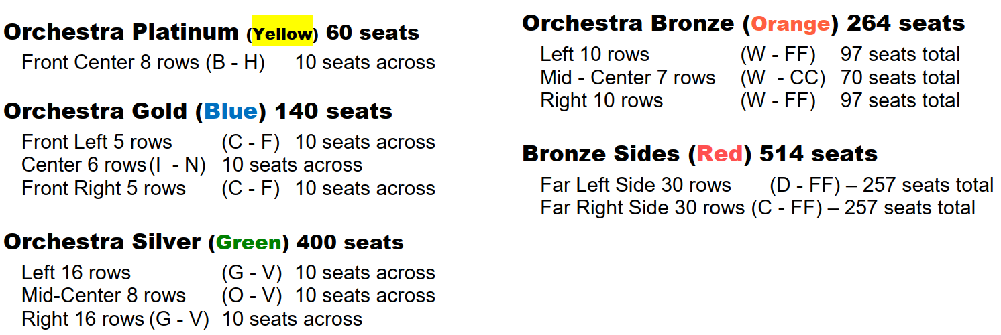
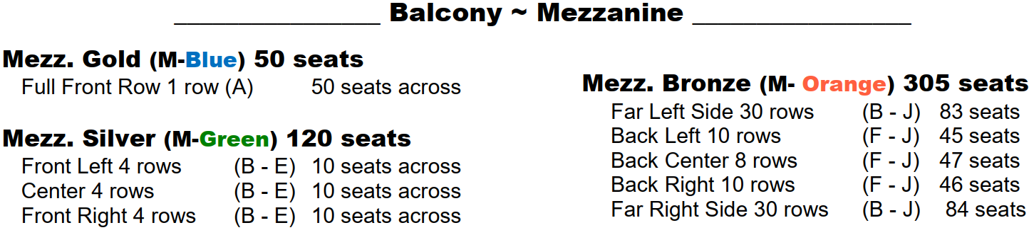

THEATER SEATING CHART - Also Online at THIS LINK

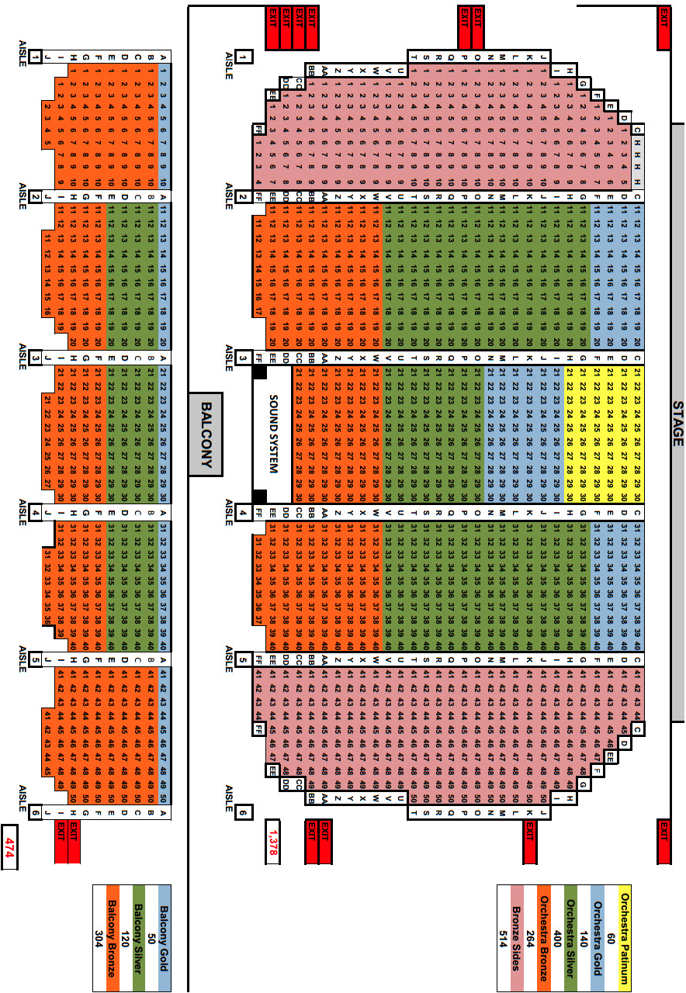

COMPLETE & RETURN THE FOLLOWING 2 PAGES

EVENT FORM ► Information needed to craft your dedicated page on our website.

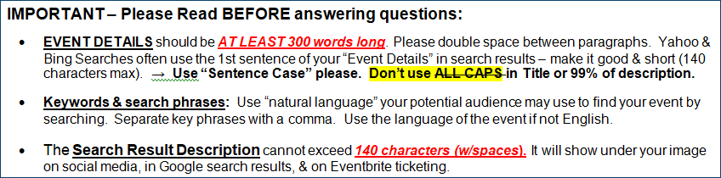

YOUR CONTACT INFO HERE: Name + Phone + Email → …

TITLE OF EVENT: → …

DATE: → … START & END TIMES: → …

DOORS OPEN: → … All ages welcome? → …

Ticket Prices: → …

Will you have a Meet & Greet? (if yes, info): → …

Event Details (300 or more words): → …

Performer Name(s): → …

Performer’s Web Links: → …

Video Link(s): → …

Event Producer Name + Link(s): → …

Public Contact Info (phone & email): → …

Event Sponsors &/Or Underwriters: → …

Search Result Description – Max 140 Characters: [character counter HERE] → …

Keywords & Search Phrases:

Co-host URL addresses for Facebook Event: → …

Add A Message To The Webmaster?: → …

Submit this Event Form along with the Ticketing Form on next page.
Ticketing Form for: Name of Event →

Enter Prices

ORCH Platinum (Yellow) $_______
ORCH Gold (Blue) $_______
ORCH Silver (Green) $_______
ORCH Bronze (Orange) $_______
BRONZE SIDES (Red) $_______
MEZZ GOLD (M-Blue) $_______
MEZZ SILVER (M-Green) $_______
MEZZ BRONZE (M-Orange) $_______

OR . . . Enter General Admission Pricing $_________
- Add Amusement Taxes (10.8%) to the ticket price(s) above? → …
Do the price(s) above include tax? → …
- Do you need any tickets printed? → …
3. Do you want to keep the BALCONY ticketing on hold until a later date? → …
4. Do you want any additional HOLDS? → …
5. What email should receive ticket sales daily reports? → …
6. Do you need any promotional codes set up? → …
7. Date you would like Ticket Sales to begin? → …
8. Meet & Greet Ticketing information: → …
9. REQUIRED: Return this form along with Imaging & Event Form. ► Tickets will NOT be created until ALL information is received.
► Submit all information to – events@copernicuscenter.org. ► Any changes must be also be submitted in writing or via email
Promoter‘s Ticketing Agreement
► By contract, ticketed admissions are only permitted through the use of the Copernicus Center ticketing vendor account unless otherwise approved by the Managing Director.

Holds, comps, and/or exchanges are subject to fees. In the event of a cancellation or any rescheduling of my event, I acknowledge that I will be held solely responsible for any and all service fees for refunded tickets and/or ticket printing charges.

- The above terms are accepted upon submission of ticketing information.

