Event Marketing & Ticketing
CopernicusCenter.org

We’re happy to help you advertise your event on our website and social media for FREE, but complete answers to ALL QUESTIONS on the following two forms plus properly formatted images are required.
►IMAGES REQUIRED for Website + Ticketing + Social Media
If a link is used on any imaging, please use ours → CopernicusCenter.org → Note: required for Lobby TV
File Formats: JPEG or PNG only – NO PDF files please

  - Resolution 100 or lower
- 300 px wide x 200 px – for Event Menu
- 350 px width x any length – for your Main Event page
- 675 px wide x 354 px – For Social Media & TICKETING
  - (Optional) 1080 wide x 1920 h Copernicus Lobby TV advertising: – Aspect Ratio 9:16
      - Images with ONLY OUR website address will be displayed → CopernicusCenter.org
  - (Optional) 1080 x 1080 Instagram image
Complete the Event & Ticketing Forms (below), https://copernicuscenter.org/eform/
  - If you have questions regarding the Event Form, please call Marleen at (412) 366-7113.
  - If you have questions regarding the Ticket Form, please call (773) 313-9157.
  - Event Forms submitted after 2:30 pm will not be posted on our website until the next business day (Monday thru Friday - 9 pm to 5 pm EST & excluding National holidays).
  - ► FEES: All required information & images NOT “Upload Ready” will incur an Editing fee.
    - $50 fee for, altering, cropping, or re-sizing images. Any text or information embellishment due to insufficient submissions on the Event Form may also incur a fee. → A $20 per change fee will be applied to any/all changes AFTER the Event URL is published on our site.
    - Our webmaster is an independent contractor and must be compensated for extra time & work performed.
  - Submit your Images. Event Form, & Ticketing Form to: Office@copernicuscenter.org
Miscellaneous Information
- OPTIONAL BUILDING BANNER: Your banner will be displayed for two weeks before your event. Dimensions are 200 x 48 ft. Cost is $300. Call 773-313-9147
- OPTIONAL: You may supply us with small promotional postcards for placement in our lobby
- Our ANNEX & KING’S HALL are available for adjunct purposes. Please see this link: https://copernicuscenter.org/facility-rental/
- The translation of this information is available at: https://copernicuscenter.org/eform/
  - En español, Po polsku, به فارسی, На български, etc. ▲ ▲ ▲
TICKET PRICING, SET-UP & INFORMATION
- The Box Office is open TWO HOURS before every event AND every weekend Saturday: 3-5pm + Sunday: 1-3pm
- When setting up prices please keep in mind that almost every seat in the house has good site lines. Only the first 4 rows on either side may have semi-obstructed views if side fill speakers are used.
- Pursuant to the American Disabilities Act, the following seats are retained for patrons requiring special seating.
HANDICAPPED SEATING: Row C: Seats 2, 3 and 4 – handicapped patrons
Row D: Seats 1, 2, 3, 4 and 5 – chaperones of handicapped patrons
- After tickets are set up you will get a daily email with ticket sales statistics. (Enter email below)
- You can set up promo codes for discounts on tickets. Promo codes can last for any time period you choose. They can represent a percentage discount or a fixed amount.
- Please let us know if you would like to transfer the taxes to the purchaser or include them in the ticket price: 9% Chicago Amusement Tax, 1% Cook County Amusement Tax & 0.8% BMI. Total 10.8% amusement taxes to the patron?
- Please indicate if printed tickets are needed. Printed tickets should not exceed 300. (extra fee)
- If an unique seating chart is needed, please download the Excel spreadsheet AT THIS LINK.

► VERY IMPORTANT: Tickets printed but not sold need to be returned. Otherwise, unsold tickets will be taxed.

________________________
Traditional Ticket Tiers for THEATER >>> See Map on next page
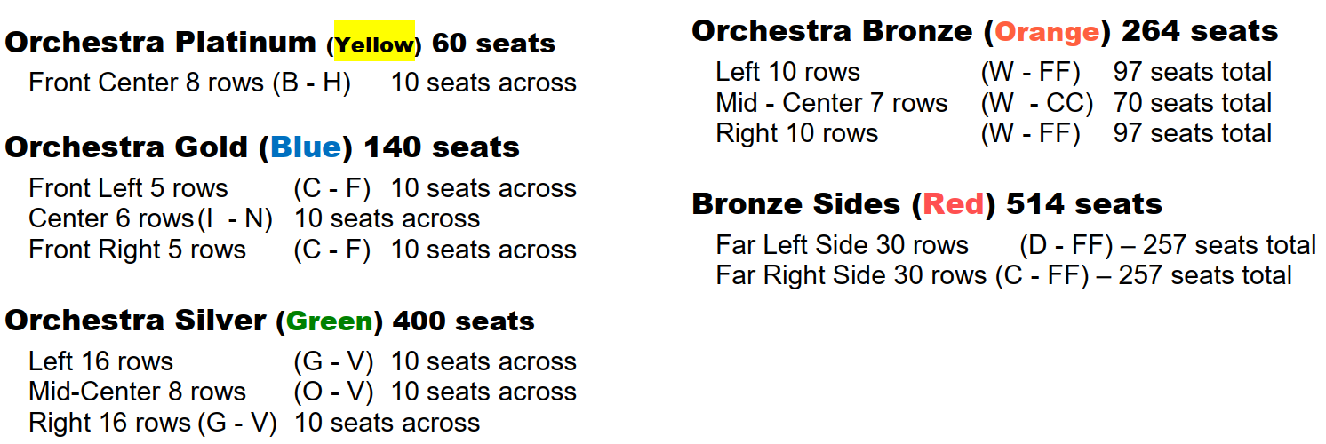
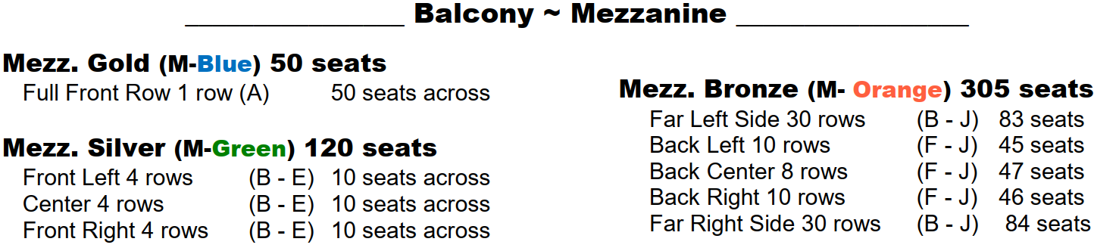
THEATER SEATING CHART - Online at THIS LINK
COMPLETE & RETURN THE FOLLOWING 2 FORMS

EVENT FORM ► Questions, call 412-366-7113 ~ Type after each “ → … “

Please do NOT use “CAPITALIZED” words or sentences unless absolutely necessary.

YOUR CONTACT INFO: Name + Phone + Email → …

TITLE OF EVENT: → … • DATE: → …

• START & END TIME (of Show/Concert) : → …

Copernicus Center DOORS OPEN: → … All ages welcome? → …

Ticket Price RANGE: → … $ to $

Will you have a Meet & Greet? (type details: i.e Before or After event): → …
Event Details – At LEAST 300 words - To sell more tickets - because search engines will NOT timely find or index your new event unless enough text is on the page. In ADDITION, poorly rated pages on our website affect our site’s ranking .... which also affects every other event on our website.
NOTE: If you copy (plagiarize) text from another website, you MUST provide the source link (full url address).
Event description → …
Performer Name(s): → …

Performer’s Web Links: → … Video Link(s): → …

Google Search Result Short Description – Maximum 140 letters + spaces: [letter/space counter HERE]
→ …

1st Sentence WITH Event Title → for Eventbrite & Facebook Event Description
Skip if “Search Result Description” (above) already includes the Event Title.
→ …

Keywords & Search Phrases: → …

Event Producer/Promoter Name + Link(s): → …

Public Contact Info (phone & email): → …

Event Sponsors & Underwriters – not you (a backlink will be made if correct link is provided):
→ …

Facebook Event: Who do we send Co-host invites to? (list LINKS ONLY - NOT TEXT)
→ …

Add A Message To The Webmaster?:
→ …

PLEASE NOTE:
Event Forms submitted after 2:30 pm will not be posted on our website until the next business day (Monday thru Friday - 9 pm to 5 pm EST & excluding National holidays).

TICKETING FORM ► Questions, call (773) 313-9157 ~ Type after each “ → …

Type Prices on lines

ORCH Platinum (Yellow) $_______
ORCH Gold (Blue) $_______
ORCH Silver (Green) $_______
ORCH Bronze (Orange) $_______
BRONZE SIDES (Red) $_______
MEZZ GOLD (M-Blue) $_______
MEZZ SILVER (M-Green) $_______
MEZZ BRONZE (M-Orange) $_______

OR . . . Enter General Admission Pricing $_________
- Add Amusement Taxes (10.8%) to the ticket price(s) above? → …
Do the price(s) above include tax? → …
- Do you need any tickets printed? → …
3. Do you want to keep the BALCONY ticketing on hold until a later date? → …
4. Do you want any additional HOLDS? → …
5. What email should receive ticket sales daily reports? → …
6. Do you need any promotional codes set up? → …
7. Date you would like Ticket Sales to begin? → …
8. Meet & Greet Ticketing information: → …
9. REQUIRED: Return this form along with Imaging & Event Form. ► Tickets will NOT be created until ALL information is received.
► Submit BOTH FORMS and all imaging to – office@copernicuscenter.org. ► Any changes must be also be submitted in writing or via email
Promoter‘s Ticketing Agreement
► By contract, ticketed admissions are only permitted through the use of the Copernicus Center ticketing vendor account unless otherwise approved by the Managing Director.

Holds, comps, and/or exchanges are subject to fees. In the event of a cancellation or any rescheduling of my event, I acknowledge that I will be held solely responsible for any and all service fees for refunded tickets and/or ticket printing charges.

The above terms are accepted upon submission of information in Event & Ticketing Forms.

TIPS:
- Transfer large files FREE & EASY with WeTransfer.com ~ no registration or account needed.
- IMPORTANT FACEBOOK INFO → ONE Facebook Event listing is better than 2 or 3. Why? Events on Facebook & numerous other sites are listed according to popularity (number of responders). We will ALWAYS send a co-host invite to all the addresses you list under the Facebook Question on the Event Form.
- Groups cannot co-host
    - To respond to a co-host request: Click the notification that says another Page has sent your Page a co-host request. • At the top of the Page's event, click Accept.
    - DON’T use the Eventbrite ticket link – Regardless of what Facebook is claiming ……. Most venues see lower ticket sales via Facebook’s direct link to Eventbrite ….. as do we.
- What is a Google Search Result Description? (or Meta Description)
  - A powerful SHORT description of your event using the performers or Event Title & keywords to attract people to learn more.
  - Here is an actual listing from Google Search. The smaller type in the image is the Meta Description (Google Search Result Short Description). See how it cuts off if it’s too long?
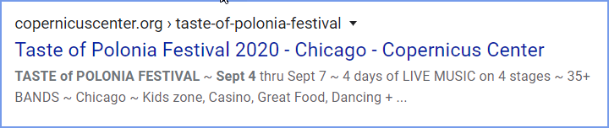
Write your Meta Description IN THE EVENT’S LANGUAGE & use as many keywords & key phrases as possible – to INCLUDE the name of the event. The top line (above description) is simply a “visual” all Google robots only search the Description to bring up results on a search. Remember – only a Maximum 140 letters + spaces: [letter/space counter HERE]

