Event Marketing & Ticketing

Thank you for your venue rental at the Copernicus Center. We appreciate your business and will help you market your event on our website www.CopernicusCenter.org & our social media.
Please complete these STEPS in the following order for marketing & ticketing.
- Notify your graphic artist that we need the following image sizes to assist you.

► A “graphic imaging” fee will be added to your invoice if all imaging is not submitted as follows
  - Resolution 100 or lower
  - Homepage Button image with clear Event Name: 150 x 150 px
  - 300 px wide x 200 px – for Event Menu
  - 350 px max width – Main Event page
  - 675 px wide x 354 px – For Social Media & Eventbrite Ticketing
  - (Optional) Copernicus Lobby TV advertising: 1080 wide x 1920 h – Aspect Ratio 9:16
  - (Optional) Instagram image – 1080 x 1080
- Complete this Event Form & Ticketing Form, https://copernicuscenter.org/eform/
  - If you have any questions regarding the Event Form, please contact our webmaster, Marleen, at her home-office (412) 366-7113
  - If you have questions regarding the Ticket Form, please contact our Ticketing Specialist at (773) 313-9157
  - Event information & imaging submitted after 2:30 pm will be posted within 24 hours of the next business day.
  - ► IMAGE EDITING FEE(s): Website & Social Media & Ticketing Images NOT “Upload Ready” (as stated above) will incur an automatic Image Editing fee.
    - $50 fee for, altering, cropping, re-sizing, or text embellishment.
    - A change fee of $20 will be applied – AFTER the Event URL is published.
  - Submit your Images. Event Form, & Ticketing Form to: Office@copernicuscenter.org
Miscellaneous Information
- OPTIONAL BUILDING BANNER: Your banner will be displayed for two weeks before your event. Dimensions are 200 x 48 ft. Cost is $300.
- OPTIONAL: You may supply us with small promotional postcards for placement in our lobby
- Your event will be promoted on our social media platforms & our RSS calendar feed.
  - A Facebook Event will be created for you. Co-host invites will be sent to you, your performers and sponsors ….. Please supply all Facebook LINKS on the form below.
- Our ANNEX & KING’S HALL are available for adjunct purposes. Please see this link: https://copernicuscenter.org/facility-rental/

TICKET PRICING, SET-UP & INFORMATION
- The Box Office is open TWO HOURS before every event AND every weekend Saturday: 3-5pm + Sunday: 1-3pm
- When setting up prices please keep in mind that almost every seat in the house has good site lines. Only the first 4 rows on either side may have semi-obstructed views if side fill speakers are used.
- Pursuant to the American Disabilities Act, the following seats are retained for patrons requiring special seating.
HANDICAPPED SEATING: Row C: Seats 2, 3 and 4 – handicapped patrons
Row D: Seats 1, 2, 3, 4 and 5 – chaperones of handicapped patrons
- After tickets are set up you will get a daily email with ticket sales statistics. (Enter email below)
- You can set up promo codes for discounts on tickets. Promo codes can last for any time period you choose. They can represent a percentage discount or a fixed amount.
- Please let us know if you would like to transfer the taxes to the purchaser or include them in the ticket price: 9% Chicago Amusement Tax, 1% Cook County Amusement Tax & 0.8% BMI. Total 10.8% amusement taxes to the patron?
- Please indicate if printed tickets are needed. Printed tickets should not exceed 300. (extra fee)
- If an unique seating chart is needed, please download the Excel spreadsheet AT THIS LINK.

► VERY IMPORTANT: Tickets printed but not sold need to be returned. Otherwise, unsold tickets will be taxed.

________________________
Traditional Ticket Tiers for THEATER >>> See Map on next page
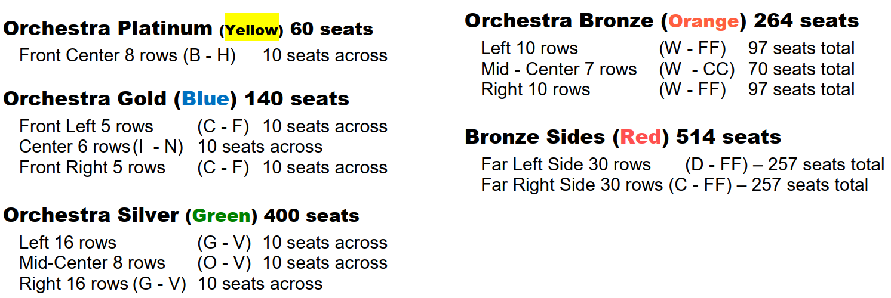
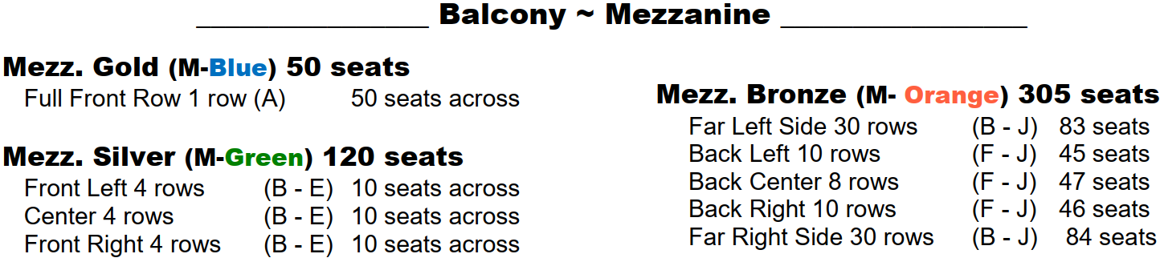

THEATER SEATING CHART - Also Online at THIS LINK

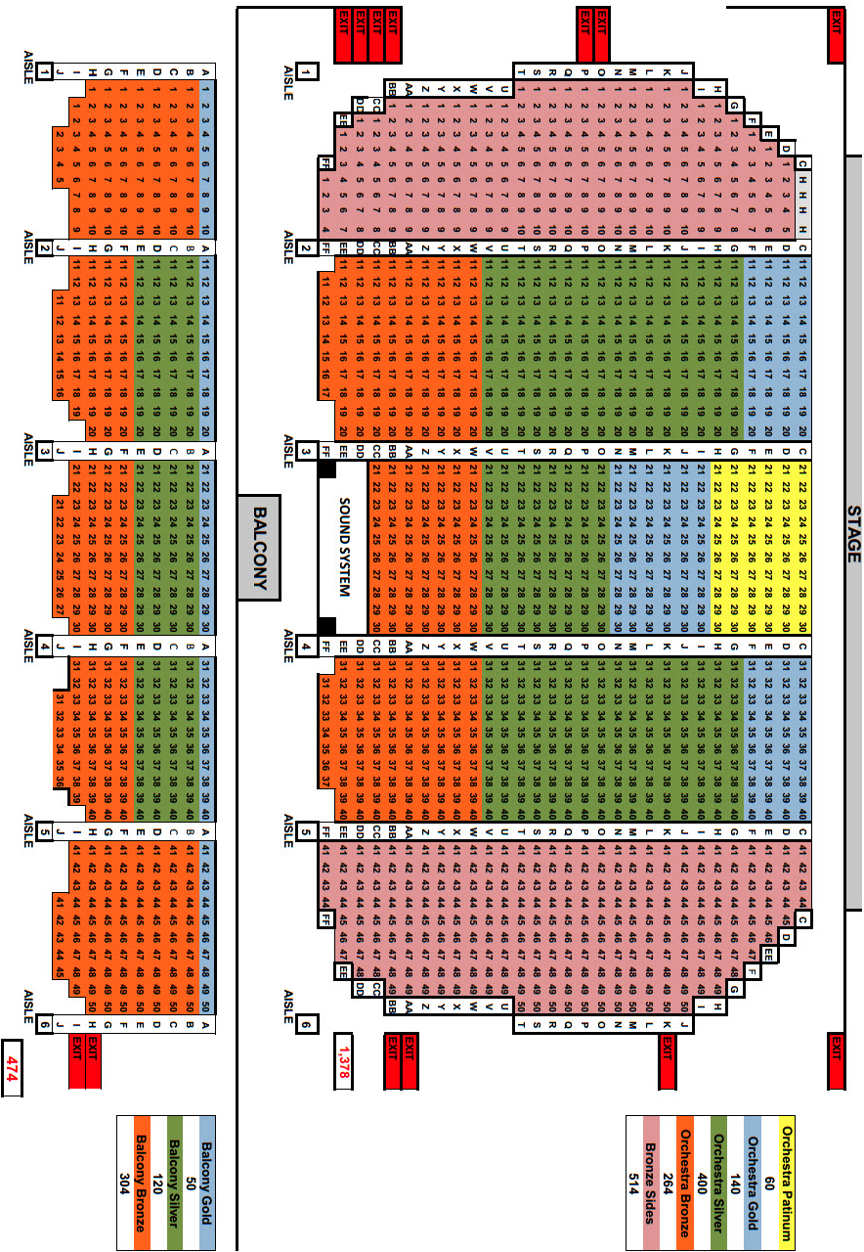

COMPLETE & RETURN THE FOLLOWING 2 PAGES
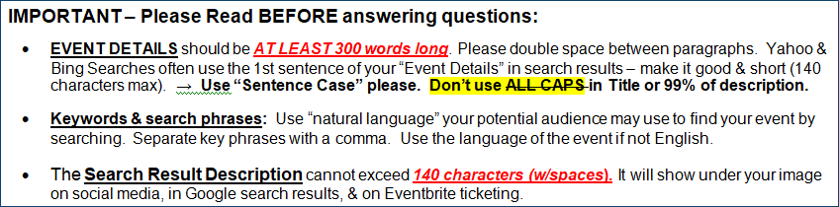

EVENT FORM ► Information for your dedicated page on our website. Type after each “ → … “

YOUR CONTACT INFO HERE: Name + Phone + Email → …

TITLE OF EVENT: → …

DATE: → … START & END TIMES: → …

DOORS OPEN: → … All ages welcome? → …

Ticket Price Range: → …

Will you have a Meet & Greet? (if yes, info): → …

Event Details (Use 300 or more words – Include Keywords & Phrases):
→ …

Performer Name(s): → …

Performer’s Web Links: → …

Video Link(s): → …

Event Producer Name + Link(s): → …

Public Contact Info (phone & email): → …

Event Sponsors &/Or Underwriters: → …

Search Result Description – Max 140 Characters: [character counter HERE] → …

Keywords & Search Phrases: → …

Co-host URL addresses for Facebook Event: → …

Add A Message To The Webmaster?: → …

Submit this Event Form along with ALL IMAGING listed on Page 1, #1 & the Ticket Form below.
Ticketing Form for: Name of Event →

Enter Prices

ORCH Platinum (Yellow) $_______
ORCH Gold (Blue) $_______
ORCH Silver (Green) $_______
ORCH Bronze (Orange) $_______
BRONZE SIDES (Red) $_______
MEZZ GOLD (M-Blue) $_______
MEZZ SILVER (M-Green) $_______
MEZZ BRONZE (M-Orange) $_______

OR . . . Enter General Admission Pricing $_________
- Add Amusement Taxes (10.8%) to the ticket price(s) above? → …
Do the price(s) above include tax? → …
- Do you need any tickets printed? → …
3. Do you want to keep the BALCONY ticketing on hold until a later date? → …
4. Do you want any additional HOLDS? → …
5. What email should receive ticket sales daily reports? → …
6. Do you need any promotional codes set up? → …
7. Date you would like Ticket Sales to begin? → …
8. Meet & Greet Ticketing information: → …
9. REQUIRED: Return this form along with Imaging & Event Form. ► Tickets will NOT be created until ALL information is received.
► Submit all information to – office@copernicuscenter.org. ► Any changes must be also be submitted in writing or via email
Promoter‘s Ticketing Agreement
► By contract, ticketed admissions are only permitted through the use of the Copernicus Center ticketing vendor account unless otherwise approved by the Managing Director.

Holds, comps, and/or exchanges are subject to fees. In the event of a cancellation or any rescheduling of my event, I acknowledge that I will be held solely responsible for any and all service fees for refunded tickets and/or ticket printing charges.

- The above terms are accepted upon submission of information.

