Event Form

To sell MORE TICKETS, please complete this form with as much detail as possible.

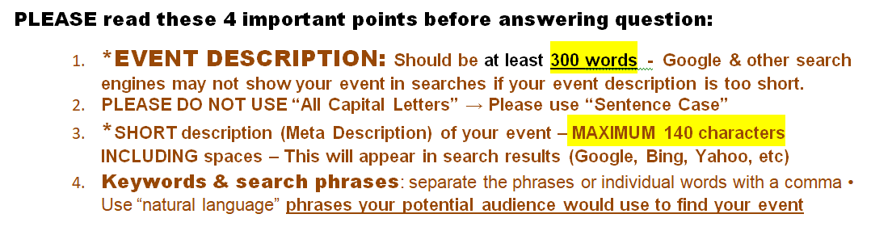

If the webmaster has questions, she needs your contact info:
Your contact info here ►Name: ►Email: ►Phone:

TITLE OF EVENT →

DATE → START & END TIME Answer →

DOORS OPEN: → APPROPRIATE FOR AGES? Answer →

TICKET PRICES Answer →

DATE TICKET SALES BEGIN --- Answer ASAP or in coordination with office
Answer →

* (See #1 above) EVENT DESCRIPTION – At least 300 words – (WHO, WHAT, ABOUT EVENT & Performers)

Answer →

PERFORMER NAME(s) →

PERFORMER’S LINKS: (Facebook, Website, Youtube) →

EVENT PRODUCER NAME OF BUSINESS → EVENT PRODUCER LINK(s) →

PRODUCER PUBLIC CONTACT INFO: (PHONE & EMAIL): →

EVENT SPONSORS: →

VIDEO LINK(s)
Answer →

* (See #3 above) SHORT Description – Max 140 characters - including spaces – See this link for “Character counter” https://www.lettercount.com/

Answer →

* SEE #4 above - KEYWORDS & SEARCH PHRASES - If a customer is searching for something to do, what phrases or words would they use to “find” your event in Chicago?

Answer →

FACEBOOK CO-HOSTS

Please list the Facebook link address for: Performers, Sponsors, and Producers.

Answer →

      - All co-hosts can edit, monitor, see stats, and post in the Facebook Event.
- An attractive “Join the Facebook Event” button image will be displayed on our website.

ADD A MESSAGE TO THE WEBMASTER:

Answer →

++++++++++++++++++++++++++++++++++++++++++++++++++++++++++++++++++++++++++++++++++++++++++++++++++++++++++++++

Images Needed (for Website & Social Media): Click links for examples
- RESOLUTION: 100 or lower
- Homepage: 150 x 150 px
- Menu System (Upcoming events page): 300 px wide x 200 px high
- Main Event Poster: 350 px wide maximum (any length)
- Social Media Image - for auto display 675 wide x 354 px

IMAGE EDITING FEE(s): Images NOT “Upload Ready” (as described above) will incur an Image Editing fee.
  - altering, cropping, re-sizing, or text embellishment $20
  - Change(s) AFTER the Event URL is published on our site $ 5 per change

Questions? Call our Webmaster Marleen: 412.366.7113 (home office)

ATTENTION PLEASE: Social Media & SERPS change very often. Please refer to the PRODUCER LINK for updates & possible new revisions to this document.

